Name:

### Score: out of

# Manjimup SHS 2015

# Year 11 Mathematics Methods

# Test 2

# Linear & Quadratic Functions

**20**

**Non Calculator Section (No calculator or notes, formula sheet provided)**

**Time: 20 minutes Marks: 20 marks**

**Question 1 [4 marks]**

The graph shows four linear functions labelled A, B, C and D. Select the correct rule for each function

from the list below. Write your answers in the table provided.

NOTE: Not all function rules will be used.

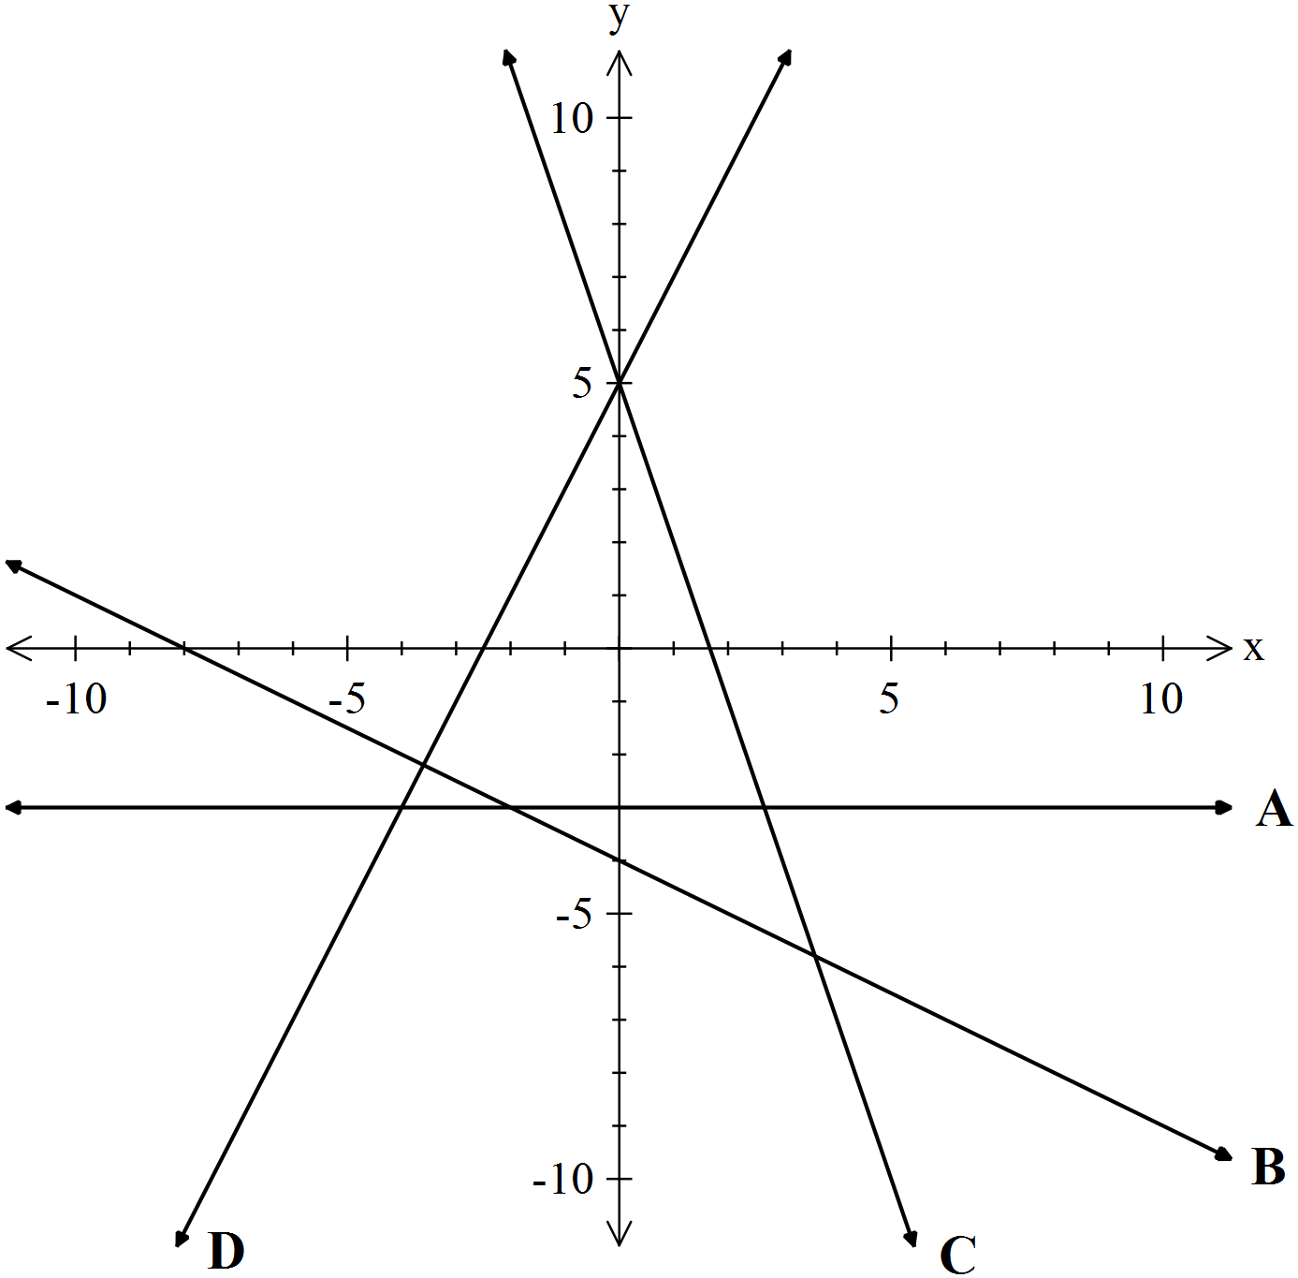

x = −3

y = −3

−3x + y = 5

3x + y = 5

x + 2y = −4

x + 2y = −8

y = 2x + 5

y = −2x + 5

|  |  |  |  |  |  |
| --- | --- | --- | --- | --- | --- |
| Line | A | B | C | D |  |
| Rule |  |  |  |  |  |

**Question 2 [2,2,2 = 6 marks]**

Determine the rule for each quadratic shown below. Write solution in suggested form.

(a)

|  |  |  |  |  |  |
| --- | --- | --- | --- | --- | --- |
| x | 1 | 2 | 3 | 4 | 5 |
| y | 2 | 8 | 16 | 26 | 38 |

In standard form y = ax2 + bx + c ………………….………….

(b)

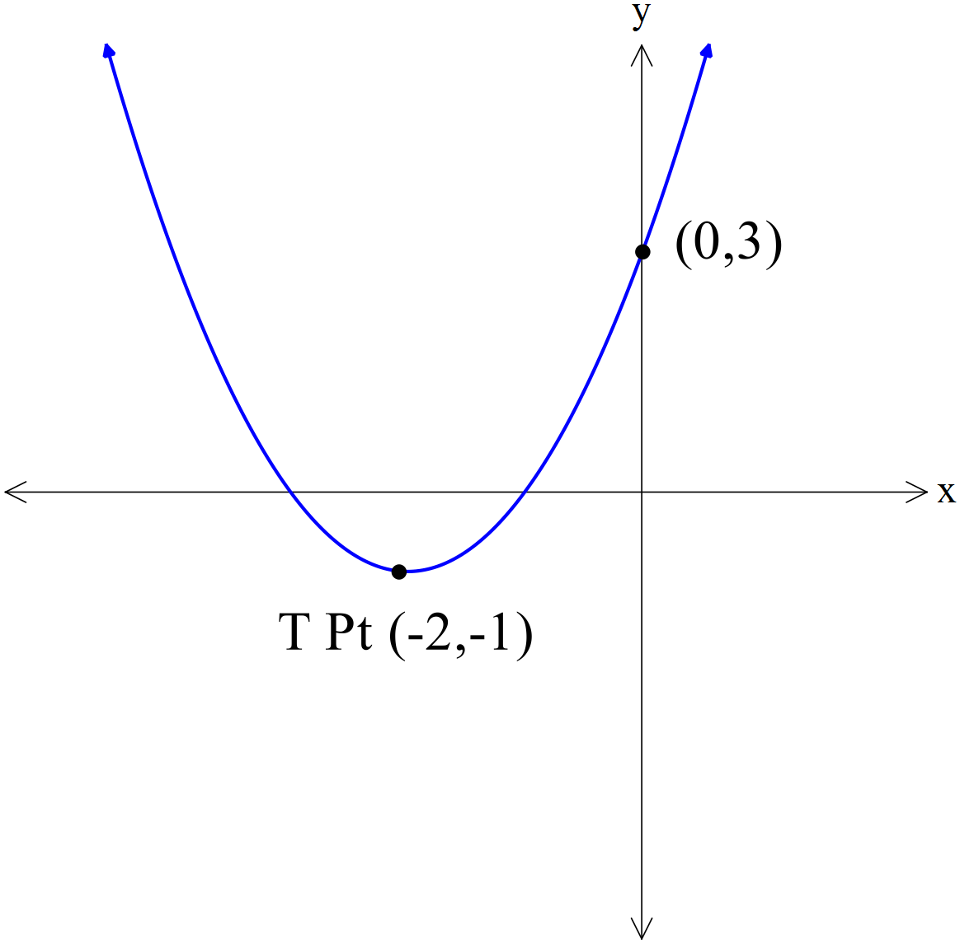

In turning point form y = a(x – h)2 + k ………………………………

(c)

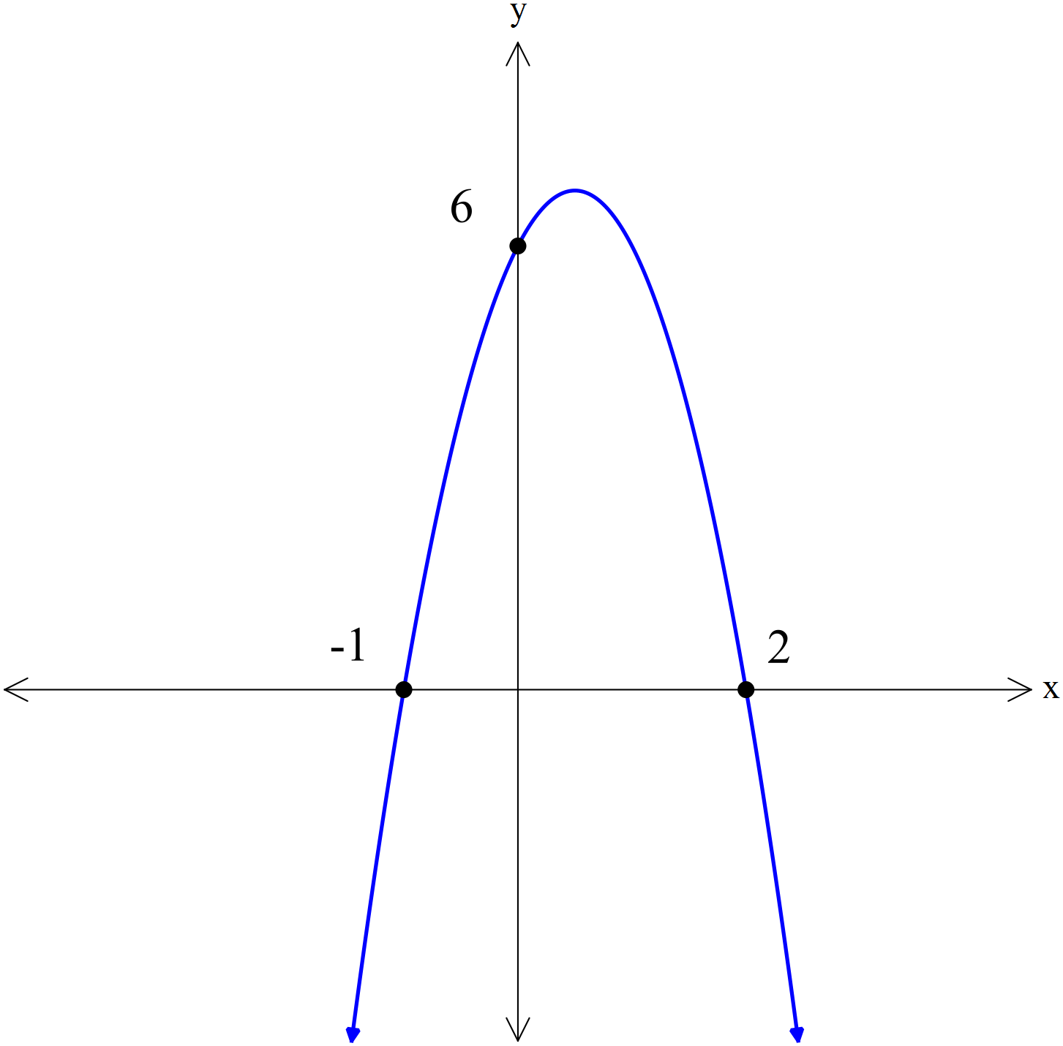

In factored form y = a(x – p)(x – q) ………………………………

**Question 3 [2,3 = 5 marks]**

Given the functions

f(x) = x2 – 3x + 11 and g(x) = 17 – 8x

(a) Determine

(i) g() (ii) f(−3)

(b) Solve

(i) f(x) = g(x). (Hint: you will need to set up and solve a quadratic equation!)

**Question 4 [2,3 = 5 marks]**

1. Determine the equation of the line that contains the point (2,7) and is *parallel*

with the line y = 3x – 1.

1. Determine the equation of the line that is *perpendicular* with the line 2y = 5x + 11

and passes through the *midpoint* of AB where A and B are the points (−6,12) and (16,−2).

Name:

### Score: out of

# Manjimup SHS 2015

# Year 11 Mathematics Methods

# Test 2

# Linear & Quadratic Functions

**33**

**Calculator Section (Calculators and 1 page (A4) of notes permitted, formula sheet provided)**

**Time: 40 minutes Marks: 33 marks**

**Question 5 [2,2,3 = 7 marks]**

Shown below is a circle and a tangent line at the point (2,4)

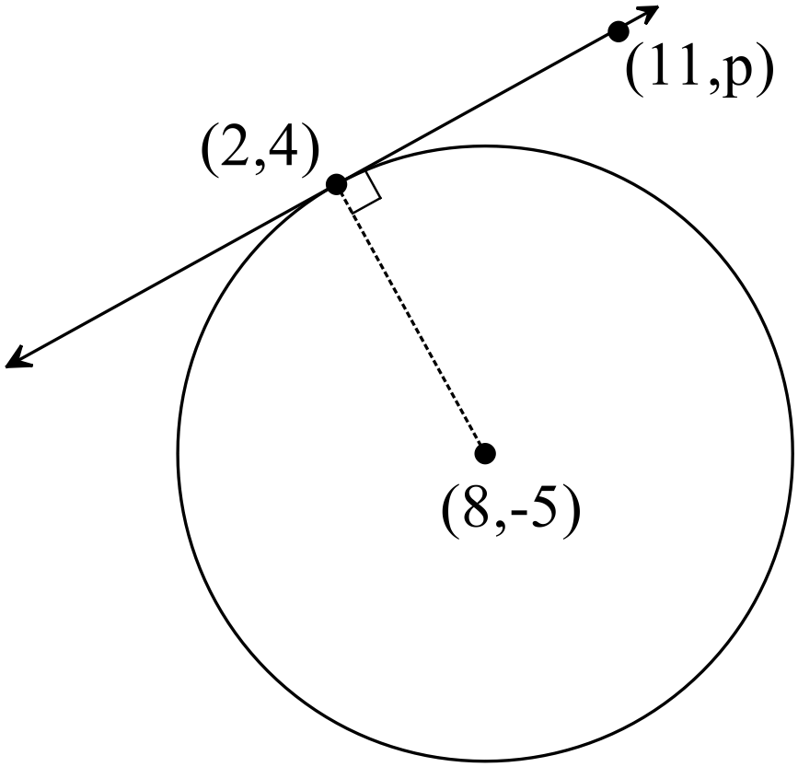

1. Determine the length of the radius of the circle, accurate to 3 significant figures.
2. Find the equation of the radius line.
3. Find the value of p, where the point (11, p) is a point on the tangent line.

**Question 6 [3,2 = 5 marks]**

1. Use the *completing the square method* to determine the turning point form for the quadratic expression

y = 2x2 + 10x + 7

i.e. rewrite the rule in the form y = M(x – N)2 + P

Clearly show all algebraic steps you used to get your answer.

1. State the turning point and rule for the line of symmetry.

**Question 7 [7 marks]**

Complete the table below.

|  |  |  |  |  |  |
| --- | --- | --- | --- | --- | --- |
| Rule | y−intercept | roots | line of  symmetry | turning  point |  |
| y = 15x2− 11x − 12 |  |  |  |  |  |
|  |  | (6,0) and (-2,0) |  | ( ___ , -8) |  |

**Question 8 [1,2,2,2 = 7 marks]**

The cost of hiring a car from Company A is given by the rule **A = 1.3k + 25**

where k is the number of kilometres that is travelled.

1. Find how much it would cost to hire a car for a day and drive 122 kilometres.

The costs associated with hiring the same model of car from two other different hire car companies for one day are as follows:

Company B A hire fee of $80 and a charge of 80 cents per kilometre travelled

Company C A hire fee of $150 and no additional charge per kilometre travelled

(b) Write down a rule for each company that will show how charges for different distances travelled are calculated.

Company B __________________ Company C __________________

(c) For what distance travelled would the hire cost from Company B be the same as the hire cost from Company C? (Indicate your method of solution)

(c) State the range of distances travelled that it would it be best to use Company A rather than either Company B or C.

**Question 9 [2,2,2 = 6 marks]**

A ramp walkway is to be built over a ravine. A river runs through the ravine. The walkway is to be attached to a supporting cable with guy wires as show in the cross sectional diagram below. Both the ramp walkway and the supporting cable are in the shape of a quadratic function. The x−axis represents the water level, the left hand edge of the ravine aligns with the y−axis and the right hand edge of the ravine is also shown in the diagram. The guy wires are evenly spaced along the ramp.

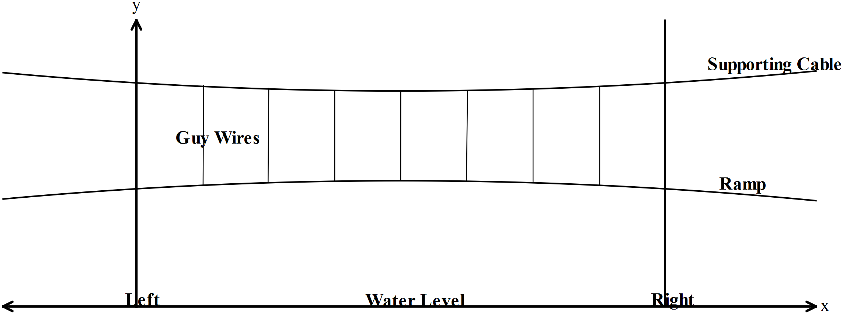

The equation of the *ramp walkway* is given by the function ***y = −0.001x2 + 0.062x + 18.04***

The equation of the *supporting cable* is given by the function ***y = 0.003x2 – 0.186x + 25.18***

(a) Find the maximum height of the ramp walkway above the water level.

(b) Determine the width of the ravine.

(c) Find the distances from the left end that the supporting cable is exactly 24 metres above the water?

**Question 10 [2,2 = 4 marks]**

Three consecutive positive integers are such that if you add the square of the smallest integer to the product of the other two integers the answer is 154. Determine the three integers.

(Note: An example of consecutive integers are 34,35,36 or -207, -206, -205)

1. Write an equation to describe this situation. Hint: Let the integers be x, x+ 1 and x +2.
2. Find the three integers.